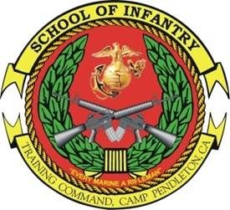COMBAT HUNTER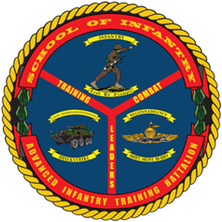
TRAINER COURSE
Course ID: M10HE42
- Purpose: The purpose of the Combat Hunter Trainer Course is to produce a Marine capable of training a more ethically minded, tactically cunning, and situational aware Marine capable of proactively identifying threats in any environment.

- Scope: The Combat Hunter Trainer Course enhances the safety and security of Marines across the range of military operations, whether in garrison, on liberty, or on the battlefield. Marines are trained to observe and recognize human behaviors, patterns and trends that are indicative of a threat and to act on that threat quickly and decisively through an improved and matured decision-making process. The Marine receives training in planning, conducting, and evaluating training events to include classes on small unit training and unit training management. Combat Hunter training includes Introduction to Combat Hunter, Observation Devices, Criminal and Insurgent Networks, Decision Cycle, Enhanced Observation, KIM Technique, Introduction to Profiling, Heuristics, Profiling Domains, Terrorist Planning Cycle, Tactical Questioning, Analyze and Interpret Spoor, Individual Actions in a Tracking Team, Track Exploitation, Leading a Tracking Team, and Tactical Site Exploitation.

- Task List:
  - 2000 Level:
    - Analyze spoor
    - Perform individual actions in a tracking team
    - Lead a combat tracking team in a follow-up
    - Develop an integrated observation plan
    - Establish and maintain a relationship
    - Integrate combat policing
    - Utilize tactical questioning
    - Profile an anomaly
    - Conduct small unit training

- Length: 3 Weeks (15 Training Days)

- Prerequisites:
    - Active duty or reserve Marine Corporal through First Lieutenant (Lance Corporals waiver-able with command endorsement documenting Marine is in leadership billet)

    - Must not have any personal, legal, or medical issues that would interfere with his ability to complete the course.

    - Complete and provide evidence of completion of the following Marine Net Courses upon check in:

      - BISC-010 Basic Instructor Skills Course

      - UT01AO0000 Systems Approach to Training

      - UT03AO0000 UTM (Platoon Level)

- Registration: Units may attempt to register students in MCTIMS utilizing CID: M10HE42. If unable to register student, contact the Combat Hunter Chief Instructor at (760) 725-6811, in order to update student allocations.

- Check-In Procedures: Students will check-in to Building 64443 (Camp Talega), Camp Pendleton, CA between 0630 and 0700 on the course convene date. Students will have a command screening checklist, waiver (if applicable), and Marine Net certificates upon check in. Students traveling to Camp Pendleton from other duty stations need to coordinate lodging arrangements with the Combat Hunter Chief Instructor at (760) 725-6811, the week prior to the course convening in order to prevent any travel/lodging issues.

